**Ideation Phase**

**Define the Problem Statements**

|  |  |
| --- | --- |
| Date | 30 June 2025 |
| Team ID | LTVIP2025TMID47516 |
| Project Name | iRevolution: Reporting and Demonstration Strategy |
| Maximum Marks | 2 Marks |

**Brainstorm & Idea Prioritization Template**:

Brainstorming provides a free and open environment that encourages everyone within a team to participate in the creative thinking process that leads to problem solving. Prioritizing volume over value, out-of-the-box ideas are welcome and built upon, and all participants are encouraged to collaborate, helping each other develop a rich amount of creative solutions. Use this template in your own brainstorming sessions so your team can unleash their imagination and start shaping concepts even if you're not sitting in the same room.

**Step-1: Team Gathering, Collaboration and Select the Problem Statement**

**Problem Statement:**

To explore and visualize the impact of Apple's iPhone in India using data analytics and Tableau. Collaboration: The team collaborated using digital tools including Zoom and Mural. The discussion focused on key challenges related to iPhone adoption in India, and brainstorming was performed using shared whiteboards.

**Objective**: To gain insights into market trends, user behavior, and cultural impact through Tableau visualizations.

**Step-2: Brainstorm, Idea Listing and Grouping**

**Ideas**:

* Track iPhone sales by region over time
* Analyze user age/income demographics
* Examine social media sentiment around iPhones
* Identify product preference trends
* Visualize iPhone adoption rates
* Monitor cultural impact using Twitter trends

**Grouped Themes:**

* Sales & Penetration
* User Demographics
* Cultural Influence

**Step-3: Idea Prioritization**

**Prioritized Ideas:**

1. Regional Sales Trends

2. Demographic Analysis

3. Social Media Sentiment Visualization

**Rationale:**

These ideas provide comprehensive insight into market penetration, user behavior, and public perception, covering both business and social impacts.

**Relevant Visualizations:**

**Example:**

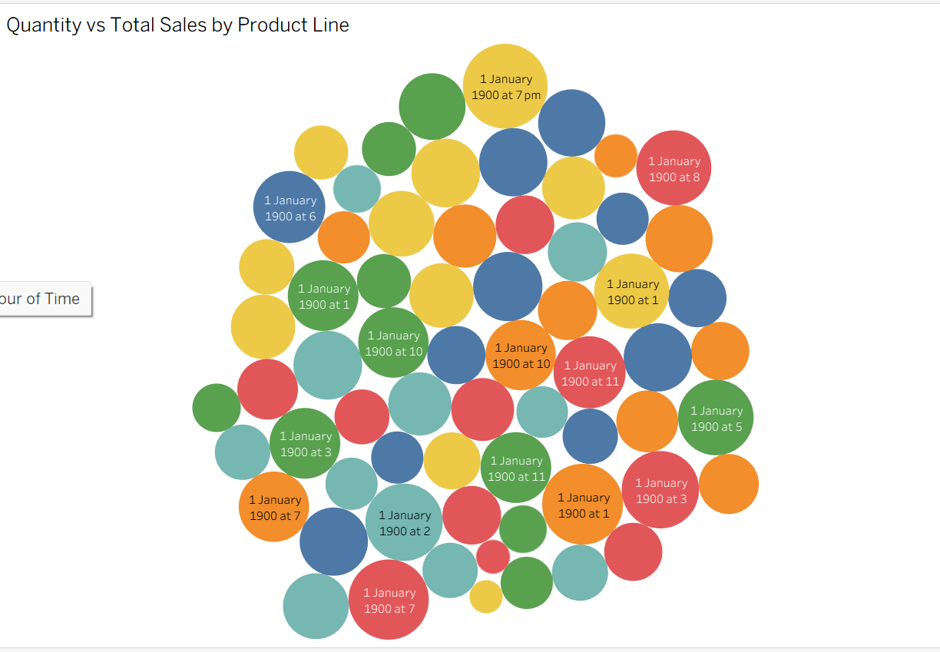

|  |  |  |  |  |  |
| --- | --- | --- | --- | --- | --- |
| **Problem Statement (PS)** | **I am (Customer)** | **I’m trying to** | **But** | **Because** | **Which makes me feel** |
| PS-1 | A market analyst | understand how iPhone adoption is changing | I have no visual or demographic breakdown | the data is scattered across sources | confused and unable to provide insights |
| PS-2 | A product manager at Apple India | identify which user segments prefer which models | the preferences vary by city, age, and income | I don’t have a unified view | uncertain about making data-driven decisions |

**Empathy map:**

